Systemwide Standard Policy Systemwide Model Policy
Corporate Model Policy No. 16668 Department: Risk Management

CORPORATE MODEL POLICY: LANGUAGE ASSISTANCE PROGRAM - INTERPRETATION AND HEARING IMPAIRED

Adventist Health Bakersfield adopts the following systemwide Adventist Health Corporate Model Policy.

POLICY SUMMARY/INTENT:
Adventist Health – (AH) will take reasonable steps to ensure that persons requiring language assistance services (such as oral language assistance or written translation) and who have Limited English Proficiency (LEP) will have meaningful access and an equal opportunity to participate and understand services, activities, programs and other benefits involving medical conditions and treatment.

Assistance will be offered for the communication of information contained in vital documents, including but not limited to, waivers of rights, consent to treatment forms, financial and insurance benefit forms, etc. All interpreters, translators and other aids needed to comply with this policy shall be provided without cost to individuals who are hearing, speech, and visually impaired. Patients/clients and their families will be informed of the availability of such assistance free of charge.

Language assistance will be provided using competent bilingual staff, providers, staff interpreters, contracts or formal arrangements with local organizations providing interpretation or translation services, or technology and telephonic interpretation services. All staff will be provided notice of this policy, and staff that may have direct contact with LEP individuals will be trained in effective communication techniques, including the effective use of an interpreter.

Regular reviews of the language access needs of our patient populations, as well as updates and monitoring of the implementation of this policy, will be completed.

DEFINITIONS:
- Interpreter – An individual who is fluent in English and in the necessary second language, and can accurately speak, read, and readily interpret the necessary second language, or a person who can accurately sign and read sign language. Interpreters need to be able to translate the names of body parts and to competently describe symptoms and injuries in both languages.

- Interpretation – Refers to spoken language

- Translation - Refers to written language

- Qualified Interpreter - Identified as proficient in sign language and in the languages of the population of the geographical area serviced who can translate the names of body parts, injuries, and symptoms.

- TTY - Text telephone yoke for the deaf – (a TTY is sometimes also called a TDD or telecommunication device for the deaf). The TTY has a typewriter keyboard with a text screen which allows persons with hearing and/or speech loss to make or receive telephone calls by typing their conversations via two-way text. The conversation is read on a lighted display screen and/or a paper printout in the TTY.

- Language Line Services – Contracted telephone interpreter service.

- Limited English Proficiency (LEP) / Limited English Speaker (LES) – Individuals whose primary language for communication is not English and who have a limited ability to read, write, speak or understand English.

AFFECTED DEPARTMENTS/SERVICES:
All departments/services accessed by the public.

POLICY: COMPLIANCE – KEY ELEMENTS

IDENTIFYING LEP PERSONS AND THEIR LANGUAGE

    - Initial assessment of communication needs will be made during the admission process, inpatient, outpatient, and emergency services.

    - Staff will identify the language and communication needs of the LEP person by using a language identification card (or “I speak cards,” available online at www.lep.gov) or posters to determine the language. The patients will be asked for their preferred language, if they have difficulty understanding or communicating this, the "Point to your language" signs/cards from the California State Board of Pharmacy will be used by staff to determine the appropriate langauge. The communication needs will be assessed by Nursing and documented in the EMR, refer to PDP policy.

    - In addition, when records are kept of past interactions with patients (clients/residents) or family members, the language used to communicate with the LEP person will be included as part of the record and reassessed as needed.

OBTAINING A QUALIFIED INTEPRETER

    - AHBD does not utilize a designated staff interpretation program

      - Maintaining an accurate and current list showing the name, language, phone number and hours of availability of bilingual staff - [this is not applicable at AHBD] :

      - Contacting the appropriate bilingual staff member to interpret, in the event that an interpreter is needed, if an employee who speaks the needed language is available and is qualified to interpret.

        - Site staff who have a limited familiarity (not deemed competent or qualified) with sign language or language/interpreter skills should interpret only in emergency situations for a brief time until a qualified interpreter can be present.

      - Obtaining an outside interpreter if a bilingual staff or staff interpreter is not available or does not speak the needed language

      - [Professional translation services are provided by Cyracom and MARTTI at no charge to our patients. To access the Cyracom Service dial 1000. Martti is accessed by using portable electronic tablets. Interpretation service for the deaf and hearing impaired is a free service provided to patients upon request. The hospital uses Life Signs for sign language interpreter services. The telephone number for Life Signs is (800) or (323) .
    - Some LEP persons may prefer or request to use a family member or friend as an interpreter. However, family members or friends of the LEP person will not be used as interpreters unless specifically requested by that individual and after the LEP person has understood that an offer of an interpreter at no charge to the person has been made by the facility. Such an offer and the response will be documented with the waiver of rights form, in the patient's medical/health record. The waiver of rights must include a statement giving the LEP Person the right to request an interpreter at any time. If the LEP person chooses to use a family member or friend as an interpreter, issues of competency of interpretation, confidentiality, privacy, and conflict of interest will be considered. If the family member or friend is not competent or appropriate for any of these reasons, competent interpreter services will be provided to the LEP person.
- See Attachment C: Waiver Request.

    - Children and other clients/patients/residents will not be used to interpret, in order to ensure confidentiality of information and accurate communication.

PROVIDING WRITTEN TRANSLATIONS

    - When translation of vital documents is needed, each unit - the responsible unit supervisor will submit documents for translation into frequently-encountered languages to the AHBD Communications Team.

Original documents being submitted for translation will be in final, approved form with updated and accurate legal and medical information.

    - Sites will provide translation of other written materials, if needed, as well as written notice of the availability of translation, free of charge, for LEP individuals.

    - Sites will post the ACA 1557 - required notices advising patients of the procedure for obtaining an interpreter in the following areas: emergency room, the admitting area, the entrance, and in outpatient areas.

      - Per California Health & Safety Code Section 1259, a notice must be posted in the emergency room, the admitting area, the entrance, and in the ouptatient areas.

    - A site's website will contain a notice that language assistance services are available; and the notice will be provided in any language that is the primary language of at least 5% of the population of the geographic area served by the hospital (but it is not required in more than five non-English languages).

    - AHBD vital documents such as consent forms, conditions of registration may be translated into additional languages over time.

PROVIDING NOTICE TO LEP PERSONS

    - AHBD will inform LEP persons of the availability of language assistance, free of charge, by providing written notice in languages LEP persons will understand.

    - Notices will instruct patients to direct complaints regarding interpreter services to [the AHBD Compliance Officer,] the U.S. Department of Health and Human Services for Civil Rights and the state, and shall provide the local address and telephone number of the state department, including, but not limited to, a
T.D.D. number for the hearing impaired. Refer to Attachment B and n/a.

STATE CONTACTS FOR COMPLAINTS REGARDING INTERPRETER SERVICES
[additional state contacts]
California Department of Public Health PO Box 997377, MS 0500
Sacramento, CA 95899-7377

For relay services for the hearing impaired or speech impaired, please call: MCI from TDD 1-800-735-2929 or MCI from voice telephone 1-800-735-2922 Sprint from TDD 1-888-877-5378 or Sprint from voice telephone
1-888-877-5379
Hawaii only ;
Hawaii only
Email: info@hicrc.org
Email: complaints@ombudsman.ha waii.gov

Oregon only:
TTY-TDD: 971-673-1222

Washington only
TTY Users dial 711
    - At a minimum, notices and signs will be posted and provided in intake areas and other points of entry, including but not limited to the emergency room, outpatient areas, labor and delivery, etc. [n/a].

    - Notification will also be provided through one or more of the following: outreach documents, telephone voice mail menus, local newspapers, radio and television stations, and/or community-based organizations - [N/A ].

MONITORING LANGUAGE NEEDS AND IMPLEMENTATION

    - On an ongoing basis, AHBD will assess changes in demographics, types of services or other needs that may require reevaluation of this policy and its procedures.

    - In addition, [ AHBD ] will regularly assess the efficacy of these procedures, including but not limited to mechanisms for securing interpreter services, reasonable response times for services, equipment used for the delivery of language assistance, complaints filed by LEP persons, feedback from patients and community organizations, etc. - [N/A] . (See Attachment A – for 2016 Top 15 Languages Spoken by Individuals with Limited English Proficiency for California, Oregon, Washington, and Hawaii).

ADDITIONAL STATE SPECIFIC REQUIREMENTS:

CALIFORNIA -

    - California Department of Public Health (CDPH) requires general acute care hospitals to send a copy of their updated policy with a description of the hospital’s efforts to ensure adequate and speedy communication between patients with language or communication barriers and staff on January 1st of each year to the local District Office.

    - Every January 1st general acute care hospitals in California must post their policy in English and in the other languages most commonly spoken in that hospital’s service area and make it available on their website.

ATTACHMENT A:

CALIFORNIA

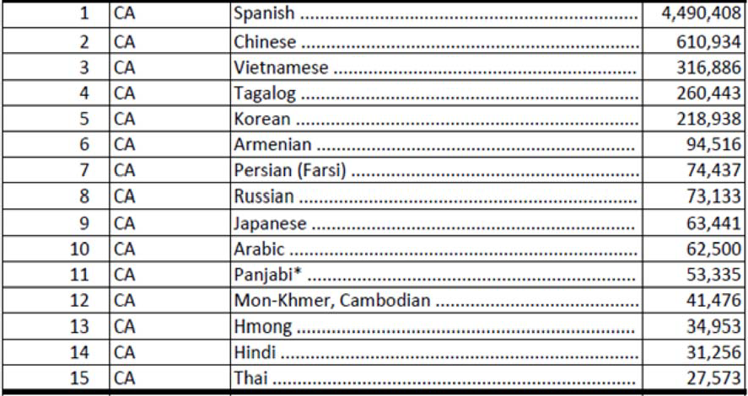

*Office for Civil Rights - OCR’s list, an asterisk after the language denotes that the estimate came from the Bureau’s detailed 2013 ACS 5-year estimates rather than from the 2014 ACS 5-year estimates.

HAWAII
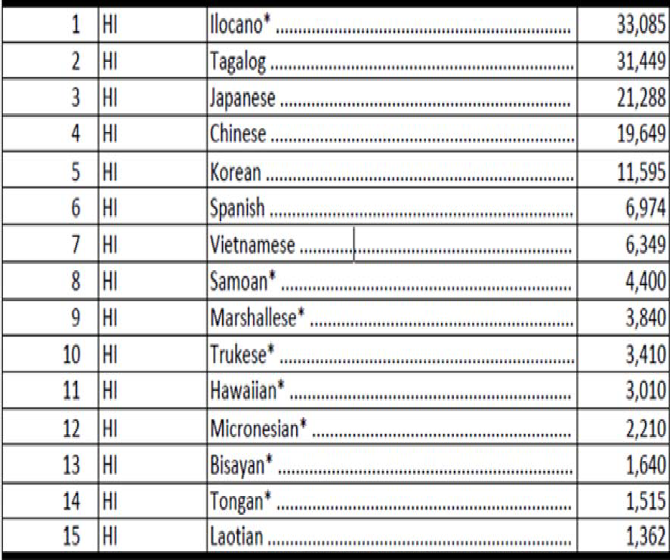

*Office for Civil Rights - OCR’s list above, an asterisk after the language denotes that the estimate came from the U.S. Census Bureau’s detailed 2013 American Community Survey’s - ACS 5-year estimates rather than from the 2014 ACS 5-year estimates

OREGON

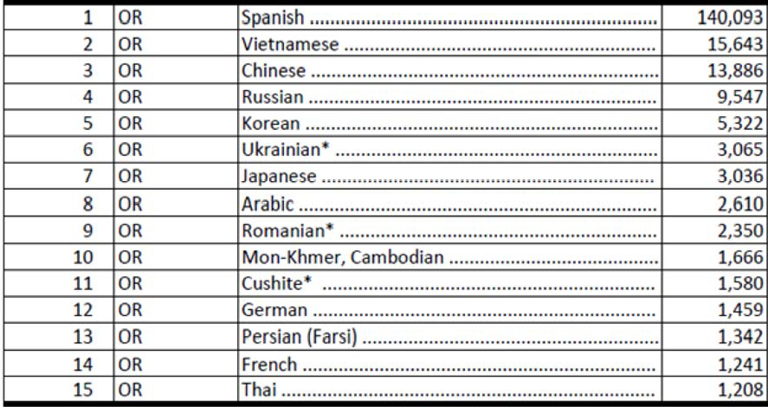

*Office for Civil Rights - OCR’s list above, an asterisk after the language denotes that the estimate came from the U.S. Census Bureau’s detailed 2013 American Community Survey’s - ACS 5-year estimates rather than from the 2014 ACS 5-year estimates.

WASHINGTON
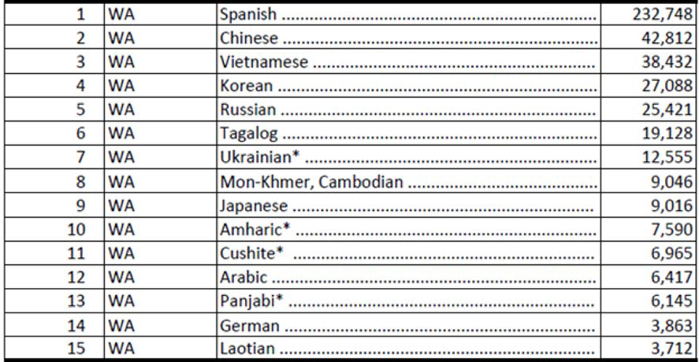

*Office for Civil Rights - OCR’s list above, an asterisk after the language denotes that the estimate came from the U.S. Census Bureau’s detailed 2013 American Community Survey’s - ACS 5-year estimates rather than from the 2014 ACS 5-year estimates.

ATTACHMENT B:

Language Assistance Program: Interpretation and Hearing Impaired Policy – Patients

Adventist Health complies with applicable Federal civil rights laws and does not discriminate and will not exclude or treat people differently because of their ability to pay, age, color, creed, culture, disability, gender identity or expression, language, marital status, national origin, religion, sex, pregnancy, sexual orientation, socioeconomic status, transgender status, type of insurance, or veteran’s status, when delivering care, treatment, services and benefits for inpatients and outpatients, including assignments or transfers within the facility and referrals to or from the facility directly or through contractual or other arrangements.

Adventist Health provides free aids and services to people with disabilities to communicate effectively with us, such as:

- Qualified sign language interpreters

- Written information in other formats (large print, audio, accessible electronic formats, other formats)

- Provides free language services to people whose primary language is not English, such as: Qualified interpreters

- Information written in other languages

If you need these services, advise your caregiver.

If you believe that Adventist Health has failed to provide these services or discriminated in another way, you can file a complaint with the entity where it occurred.

Entity Name: [ Adventist Health Bakersfield ]
Contact Person: [ Risk Manager/Patient Care Advocate ] Telephone Number: [ (661) ]
TDD number: [ (661) ]
You have the option of filing a grievance with [ California Department of Public Health ] and the U.S. Department of Health and Human Services, Office for Civil Rights. If you need help filing a grievance, [ Risk Manager/Patient Care Advocate ] is available to help you.

A civil rights complaint with the U.S. Department of Health and Human Services, Office for Civil Rights, can be electronically filed through the Office for Civil Rights Complaint Portal, available at https://ocrportal.hhs.gov/ocr/portal/lobby.jsf , or by mail or phone at:
  - Department of Health and Human Services 200 Independence Avenue, SW
Room 509F, HHH Building Washington, D.C. 20201
1-800-368-1019, (TDD)
Complaint forms are available at http://www.hhs.gov/ocr/office/file/index.html.

ATTACHMENT C: WAIVER REQUEST FOR LANGUAGE ASSISTANCE SERVICES

I, , understand that I have the right to be provided with a free qualified sign- language interpreter by an agency that will allow me to communicate with Adventist Health staff.

PLEASE FILL OUT ALL THAT APPLY:

    - I prefer to use a sign-language interpreter as necessary.

    - My preferred method of communication is . I will be communicating using .

    - I prefer the person with me to interpret. My interpreter has agreed to accurately speak, read and readily interpret the necessary second language, or can accurately sign and read sign language. The person interpreting for me can translate the names of body parts and is able to competently describe symptoms and injuries in both languages. Note: A minor - (younger than 18 years old) cannot interpret unless there is no qualified interpreter and there is an imminent threat to safety or welfare to you. Please fill out who will interpret for you.

Name
Address
Telephone This person is my

I understand that I can change my mind about getting an interpreter at any time. If my decision changes regarding the use of an interpreter, I will notify an Adventist Health staff member immediately.

Signature Date Time

Print Name

Witness Signature and Title: (required for patients unable to sign or without a representative)

Witness Signature: Date:

Time
Printed Name

Interpreter Signature:

Interpreter Printed Name:

Language used for translation of document:

Date: Time:

Adventist Health Waiver Request for Language Assistance Services
Page 1 of 1

ATTACHMENTS:
(REFERENCED BY THIS DOCUMENT)

OTHER DOCUMENTS:
(WHICH REFERENCE THIS DOCUMENT) FEDERAL REGULATIONS: ACCREDITATION:
http://www.hhs.gov/ocr/office/file/index.html https://ocrportal.hhs.gov/ocr/portal/lobby.jsf
ATTACHMENT A - Language Assistance Program - Interpretation and Hearing Impaired Policy - Top 15 Languages Spoken by Individuals with Limited English Proficiency for CA, HI, OR, WA
ATTACHMENT B - Language Assistance Program - Interpretation & Hearing Impaired Policy - Patient Notice ATTACHMENT C - Waiver Request for Language Assistance Program - Interpretation and Hearing Impaired Policy
Point to Your Language Point to Your Language

CALIFORNIA: Title 22, CCR, Sections 70721 (general acute care hospitals) and 71521 (acute psychiatric hospitals); California Health and Safety Code Section 1259; California Telephone Access Program (CTAP); AB389 (chapter 327, Statutes of 2015)
HAWAII: Not applicable
OREGON: Not applicable
WASHINGTON: Not applicable

REFERENCES: Affordable Care Act, Section 1557 CMS:
482.13; 483.10; 485.635
Joint Commission:
PC 02.01.21 EP01 and EP02 RC 02.01.01 EP 01
PC 02.03.01 EP01
RI 01.01.01 EP05
RI 01.01.03 EP 01 and EP 02
HR 01.02.01 EP 01

ADVENTIST HEALTH SYSTEM/WEST POLICY OWNER:
Program Manager, Regulatory

ENTITY POLICY OWNER: Administrative Director, Organizational Performance

APPROVED BY: ADVENTIST HEALTH
SYSTEM/WEST:

( 07/11/2017 ) Clinical Best Practice Committee, ( 11/21/2017 ) Clinical Cabinet (CC)

ADVENTIST HEALTH SYSTEM/WEST INDIVIDUAL:
ENTITY: ( 01/03/2018 ) Policy Review Development Committee (PRDC), ( 01/04/2018 ) Patient Care Coordinating Council, ( 02/01/2018 ) Medical Executive Committee (MEC), ( 07/09/2018 ) Governing Board (GB)
ENTITY INDIVIDUAL:
REVIEW DATE: 01/07/2019
REVISION DATE: 11/28/2017
NEXT REVIEW DATE: 01/07/2020
Paper copies of this document may not be current and should not be relied on for official purposes. The current version is in Lucidoc at
https://www.lucidoc.com/cgi/doc-gw.pl?ref=ahsjch:16668$0.

